- There are some basic operations in GIT while dealing with our project
- initialize
- Add
- Commit
- Push
- Pull
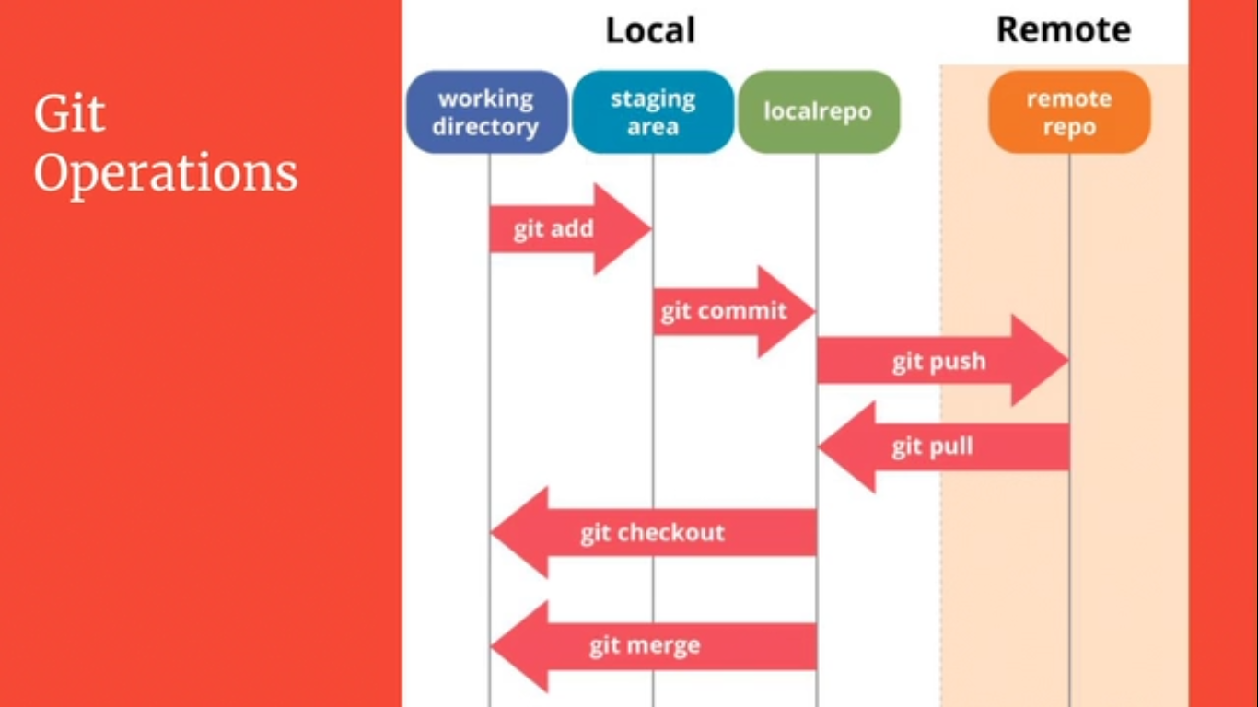

- The above diagram visualize the usage of basic operations.
- First of all the current directory in which you have kept your project need to be initialized by the command ''git init''.
- command ''git add'' enable you to select only selected files to be committed and pushed. for examples if project is consist of 50 files and you want to commit only 25 files then git add would enable you for this operation.
- next command ''git commit'' makes snapshot of your project and saves in the local repository i.e. system's hard disk.
- command ''git push'' will upload and your changing on the server.
- command ''git pull'' will fetch the project with latest changing to your local repository.

- There are some advance operations as well for example branching, merging, rebasing
- There are some important terms you must know, That are
- Repository : It is the hidden folder with the name .git in in the particular directory which you initialize as git repository. It accumulates all history about versioning, commits, and metadata of your project.
- Working Folder : Working folder is nothing but the root folder of your project where you keep all files of your project.
- File status : Every file has some status in the working folder. Diagram below illustrates the life cycle of file status.
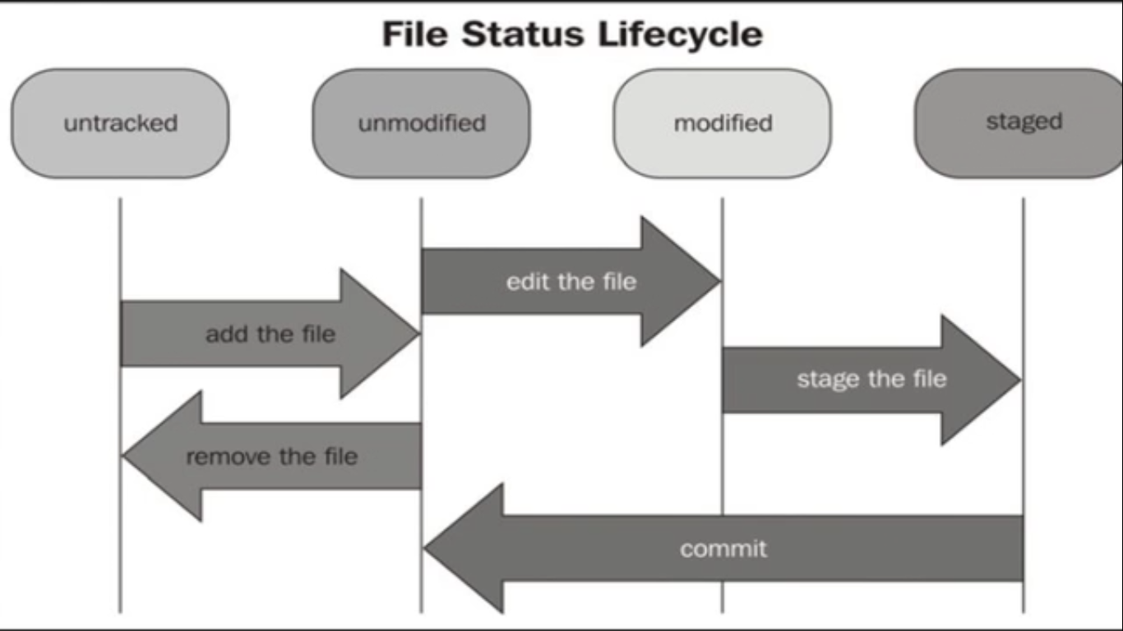

- Untracked : For example you made a working folder containing your project by command git init and then you made a new file in working folder so git will not recognize the changes that you will made in this new file until you add this into git repository.
- Unmodified : Once you add the file by command git add it will be added to the git repository and this status is known as unmodified. After it git will track the changes you will made in this new file.
- Modified : After adding the new file in git repository, if you made change in the file then its status will be change to modified.
- Staged : Once you finished with the change in the new file, command git add will stage the new file for commit.
- Commit : To make the snapshot of your change in the new file of your project you have to commit the change and after commiting the status of the file will again change to unmodified and this sequence will carry on unless you remove the file.

NOTE: (It is the life cycle of status of any particular file in your working directory)

- Head : Head denotes the current branch or version of the project. In other words head represents last commit.
- Commit Hash : Every commit has a 41 characters unique code which distinguish it from other commits is known as commit hash.
- UN-Staging or (git reset): For example you have 4 new files and you want to stage only two of them but mistakenly you staged all the files through command git add . So you can un-stage your files through command git reset.

Note : (changes will remain only files will be unstaged)
- Git reset --hard : Through this command you will not only unstage the files but also be able to undo the changes you have made.
- Ignore Files : If you are working on a project and project folder contain multiple files which aren’t concerned to your part, so you can ignore them by making a new file with extension .gitignore and adding that unwanted files,extensions,folders,directories etc. i.e.

*.txt

*.doc

Home/IOT/Practice

.gitignore

